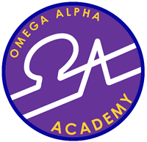 OMEGA ALPHA ACADEMY
Is Now Hiring:
High School ELA Teacher
Instruct high school ELA studies subject (English, USA History, USA AZ Government & Civics) Prepare course objectives and study outlines following the curriculum guidelines and requirements. Devise developmental objectives for required knowledge. Monitor, assess, and respond to student specific subject skill levels. Administer lessons, homework, tests and keep up with students’ academic records. Implement and follow behavioral standards in the classroom for orderly and conducive learning. Develop and implement lesson plans using a variety of instructional methods and materials. Coordinate efforts both horizontally and vertically with other teachers to better meet the student’s needs. Other requirements available upon request.

Requirements:
*Bachelor's degree.
*Minimum of 2 year experience preferred; not required.
*Valid Arizona Teaching certificate (A.R.S. & 15-502.B).
* Valid Arizona Fingerprint Clearance Card required upon hiring.
* Willingness to work with others.
*Computer literate.

Job Type: Full-time
If interested please inquire at:
Omega Alpha Academy
1402 San Antonio Ave.
Douglas, AZ 85607
Phone: (520) 805-1261 x 212
Fax: (520) 805-1272
rugalaz@oaak12.org (Rubi I. Galaz)

